2012 Hilldale School Science Fair Project Proposal
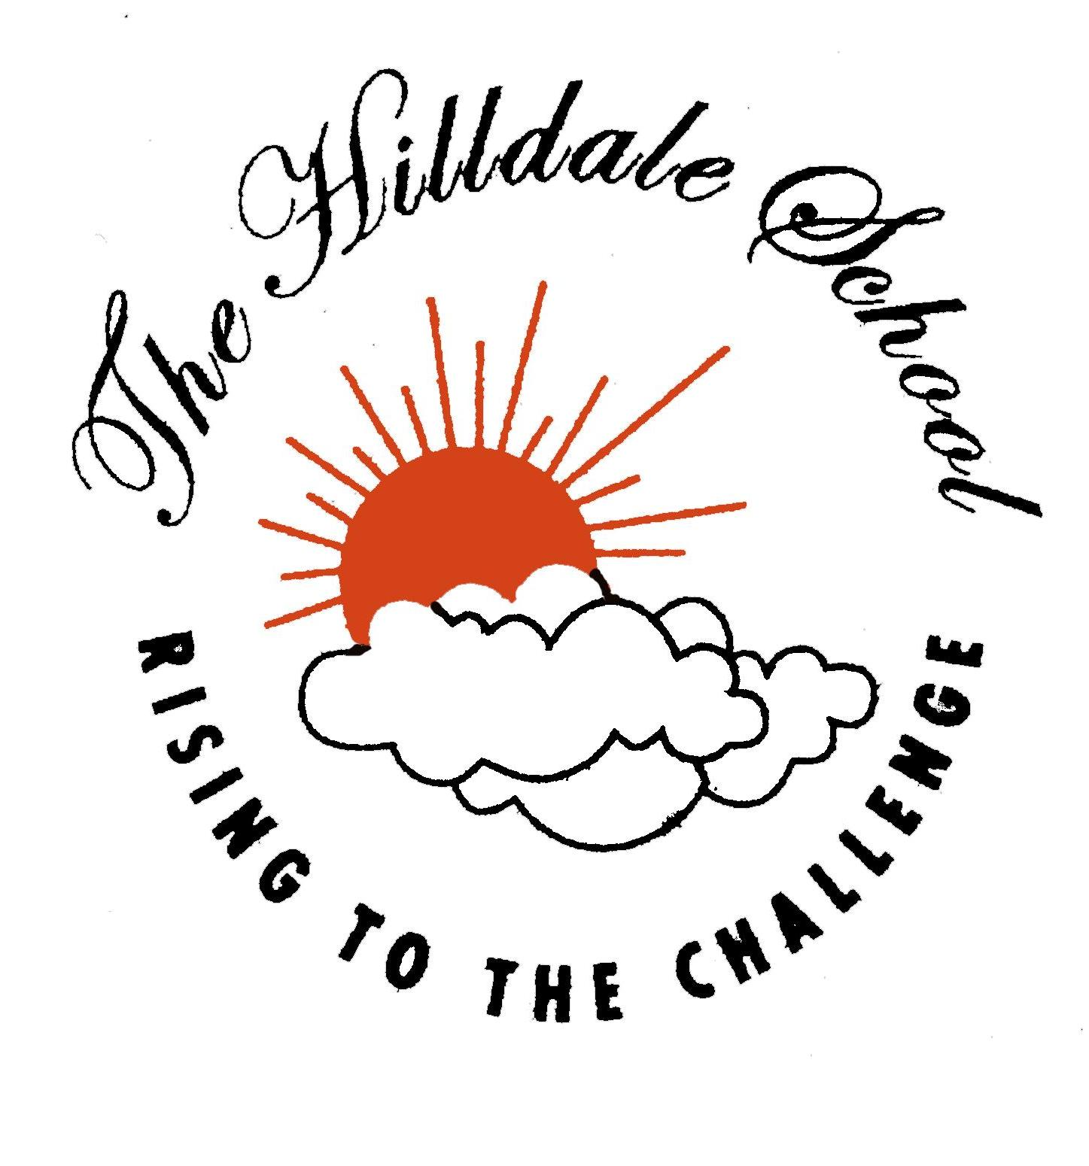
3rd – 8th Grades
DUE 10/1/12 (to be returned by teacher 10/5/12)

Student Name: ____________________________________ Grade: _______

Project Type 3rd-8th: (please circle)

Experiment (all variables are controlled) Scientific Study (only 5-8th Grades can choose)

PURPOSE (QUESTION): (What scientific question do you want to research and understand further? This MUST be something that is testable).

________________________________________________________________________________

________________________________________________________________________________

What is your manipulated (independent) variable? (What are you setting up to be different?)

________________________________________________________________________________

What is your responding (dependent) variable? (What is reacting to the manipulated variable?)

________________________________________________________________________________

What is the control group? (What part of the experiment are you keeping the same?)

________________________________________________________________________________

What other aspects will you keep constant? (What else are you going to keep the same?)

________________________________________________________________________________

What is your operational definition? (How are you going to measure the change specifically? Remember to use the metric system.)

________________________________________________________________________________

Project Title: (if known)

________________________________________________________________________________

□ Approved by teacher

□ NOT Approved by teacher

If idea is rejected, teacher’s reason or suggestion on how to get project approved:_______________

________________________________________________________________________________

________________________________________________________________________________

FOR PARENTS:
I am aware of this project and understand that this should be my child’s work and not my own, but am willing to guide him or her to achieve a successful science fair project.

If approved, Parent Signature: ____________________________________
2012 Hilldale School Science Fair Project Proposal
3rd – 8th Grades
DUE 10/1/12 (to be returned by teacher 10/5/12)

Student Name: Joe Schmoe Grade: 5

Project Type 3rd-8th: (please circle)

Experiment (all variables are controlled) Scientific Study (only 5-8th Grades can choose)

PURPOSE (QUESTION): (What scientific question do you want to research and understand further? This MUST be something that is testable).

What effect does fertilizer have on plant growth?

What is your manipulated (independent) variable? (What are you setting up to be different?)

The amount of fertilizer that I am using is my manipulated variable.

What is your responding (dependent) variable? (What is reacting to the manipulated variable?)

The growth in vertical height of the plants is my responding variable.

What is the control group? (What part of the experiment are you keeping the same?)

The plant that does not receive any fertilizer is my control group.

What other aspects will you keep constant? (What else are you going to keep the same?)

I will use the same type of plants. I will keep the light, temperature, and time of day that I record the results the same.

What is your operational definition? (How are you going to measure the change specifically? Remember to use the metric system.)

I will measure how tall each plant grows vertically in centimeters.

Project Title: (if known)

The Fertilization Factor

□ Approved by teacher

□ NOT Approved by teacher

If idea is rejected, teacher’s reason or suggestion on how to get project approved:_______________

________________________________________________________________________________

________________________________________________________________________________

FOR PARENTS:
I am aware of this project and understand that this should be my child’s work and not my own, but am willing to guide him or her to achieve a successful science fair project.

If approved, Parent Signature: ____________________________________

